Input, Output параметры хранимых процедур

− Example needed for input and output parameters on Stored procedure

− call Procedure_name ( Input1, Input2, Input3, ?, ?)

I've not used out parameter in the last one, since I was using EXECUTE IMMEDIATE. If you are using EXEC, then you would need an output parameter to hold the result.
Have a look on the sample procedure here:
SAP HANA: Generic Procedure using Arrays to Load delta data into Tables
SAP HANA: Handling Dynamic Select Column List and Multiple values in input parameter

−
Creating table type:
create type tt_purchase AS table (
EBELN NVARCHAR(10), --EKPO.EBELN,
MATNR NVARCHAR(18), --EKPO.MATNR,
BUKRS NVARCHAR(4), --EKPO.BUKRS,
WERKS NVARCHAR(4), --EKPO.WERKS,
EKORG NVARCHAR(4), --EKKO.EKORG,
WAERS NVARCHAR(6) --EKKO.WAERS
);

Creating stored procedure:
create procedure prc_PO_Details(IN MATNR NVARCHAR(18), IN WERKS NVARCHAR(4),
OUT RES tt_purchase)
LANGUAGE SQLSCRIPT READS SQL DATA WITH RESULT VIEW EKKOVIEW AS
BEGIN
RES = SELECT B.EBELN, B.MATNR, B.BUKRS, B.WERKS, A.EKORG, A.WAERS
FROM EKKO A, EKPO B
WHERE A.EBELN = B.EBELN AND B.WERKS = :WERKS AND B.MATNR like :MATNR;
END;

Calling the above stored procedure with inputs and outputs:
call prc_PO_Details('TEST_MATERIAL', '1234', null);

2. Using cursors:
CREATE PROCEDURE cursor_test(IN article VARCHAR(20))
LANGUAGE SQLSCRIPT AS
val decimal(34,10) := 0;
CURSOR c_cursor1 FOR
SELECT "article_no", "store_no", sum("qty"), sum("price") as "price"
FROM article_perish where "article_no" = :article
group by "article_no", "store_no"
order by "article_no", "store_no";
BEGIN
FOR r1 AS c_cursor1
DO
val := :val + r1."price";
END FOR;
select val from dummy;
END;
call cursor_test('A001')

Note: The best practice is to avoid usage of cursors in the stored procedures, because you will get performance issue if the data volume is large.

− I had some questions on the example that Yogesh Krishnamurthyh had posted.
The call statement used here is call prc_PO_Details('TEST_MATERIAL', '1234', null);
1. I see that you have specified output parameter as null. Can you please elaborate on why this has been done?
2. What if I want to supply a list of values for both the input parameters?

−
1. Since, I am calling this stored procedure as a simple SQL script, we cannot have the variable names in input/output. But, programmatically, you can update input variables and output variables. You can have output in two ways, a) Normal output variable, b) Table type. The above example deals with output of table type. In my example, I have created the table type (tt_purchase) and the output of the select statement will be stored in this table(tt_purchase).
2. If you want to pass the list of values, you can create the table type and insert the data in the table type and pass the table type name in the input parameter

call prc_tt_test(tt_order, tt_site, null)

where tt_order and tt_site are the two tables(table types) where you can insert your data into the table type and give input to the stored procedure.

− Thanks, I tried this out and got the output. The procedure I build is the one below:

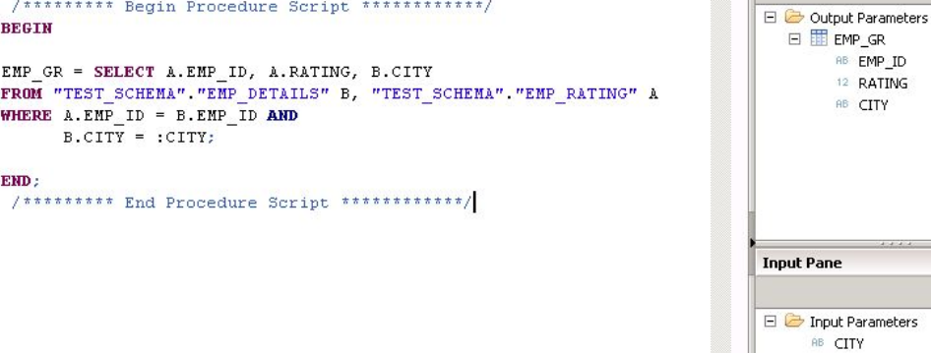
Now I have 2 questions.
- Can you tell me what would the corresponding CE (Calculation logic) logic be for the above code?
2. I was trying out a simple CE function based on some document that I found. It's giving me errors and I can't understand how to make it work.

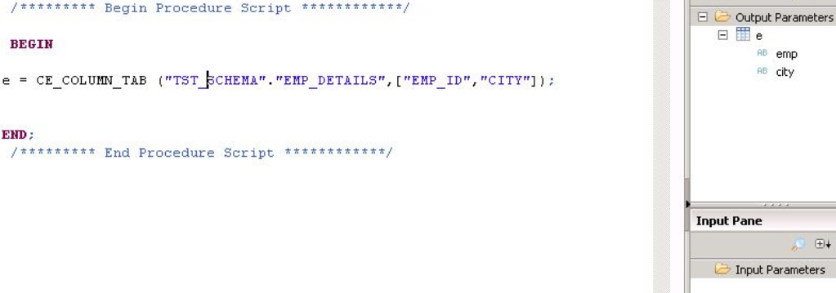
− You may have to use CE_COLUMN_TABLE and CE_JOIN to get the equivalent of your SQL query.
Have a look on this blog, where I used CE Functions, which may help you to give some idea.
SAP HANA: Dynamic Ranking using Script based (SQL Script) Vs Graphical Calculation view Vs Script based (CE Functions)

− By looking into your SQL script, the equivalent CE funtion can be
out_tab = CE_JOIN("EMP_DETAILS","EMP_RATING", [EMPID, EMPID], [EMP_ID, RATING, CITY]).

CE_Built In Function

SQL
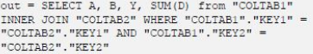

− Now I have 2 questions,
1. As you saw in my first screenshot that city has to be an input parameter used in the where clause.
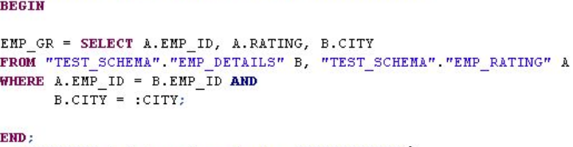
How will that be handled?
2. If I had join based on 2 fields - for example the join should be based on EMPID and CITY.

−
- For city has to be an input parameter you need to use CE_PROJECTION for it.
CE_PROJECTION(<var_table>, <projection_list>[, <filter>])

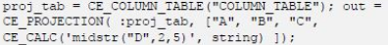
что эквивалентно
- For join based on 2 fields
CE_JOIN (<left_table>, <right_table>, <join_attributes> [<projection_list>])
Note: The joining column names from the both tables must be of same name.
See a sample here:
DROP PROCEDURE PROCWITHRESULTVIEW;

CREATE PROCEDURE ProcWithResultView(IN lt_employee EMPLOYEE, IN lt_role ROLE,
OUT EMPLOYEE_ROLE EMPLOYEE_ROLE)
LANGUAGE SQLSCRIPT READS SQL DATA WITH RESULT VIEW ProcView AS
BEGIN
-- To do filtering
EMPLOYEE_FILTER = CE_PROJECTION(:lt_employee,["ID","NAME","LAST_NAME","ROLE_ID"],
'"ID" > 3');
-- To Join
EMPLOYEE_ROLE = CE_JOIN(:EMPLOYEE_FILTER, :lt_role, ["ROLE_ID"], ["NAME", "LAST_NAME",
"ROLE_ID", "ROLE"]);
END;

call ProcWithResultView ('EMPLOYEE', 'ROLE', ?)

− I tried to recreate the program that you are trying to do
in my HANA system.
Below is the SQL that you are using translated to a CE version:
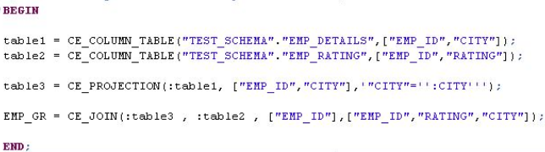

Implementing RANK using Graphical calculation View

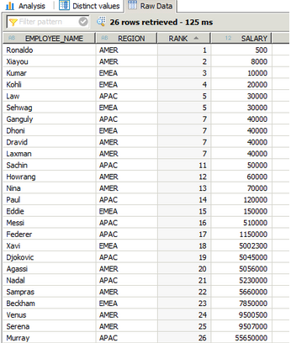

Projection 1 & 2 : We select the required columns i.e Employee Name, Region and Salary and create a dummy column with constant value 1 as shown below:

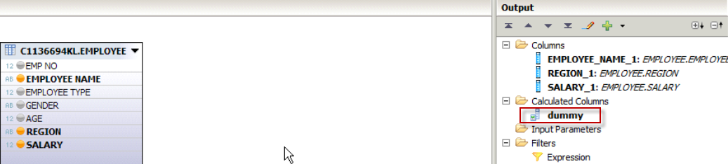

Join 1: (Projection 1 & 2 joined on dummy column) – каждая запись Projection’s 1 с каждой записью Projection’s 2
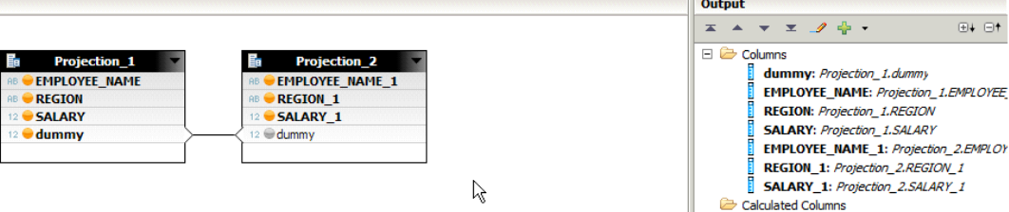
Aggregation 2 : (Aggregate salary as “Minumum” and add “dummy” column to apply the group by) – минимальная зарплата
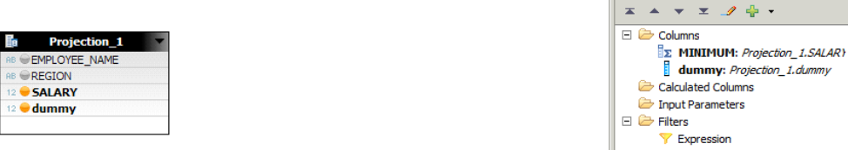

Join 2 : (Joining Aggregation 2 and Projection 1 on dummy column) – в каждой строке - зарплата и мин. зарплата
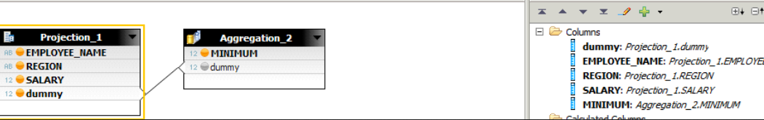

SELECT a1.Id, a1.Name, a2.min_Id FROM [dwbeloil].[dbo].[Azs_xxx] as a1
join
(SELECT Expr1, min(Id) as min_ID FROM [dwbeloil].[dbo].[Azs_xxx] group by Expr1) as a2
on a2.Expr1 = a1.Expr1
order by a1.Id

Projection 3 : (Apply filter SALARY_1 < SALARY к Join_1) – в матрице останутся записи, где левая зарплата больше правой
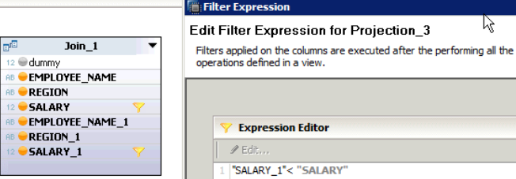

SELECT * FROM [dwbeloil].[dbo].[Azs_xxx] as a1
join
(SELECT * FROM [dwbeloil].[dbo].[Azs_xxx]) as a2
on a2.Expr1 = a1.Expr1
where a2.Id < a1.Id
order by a1.Id

